|  |
| --- |
| PT. BERLIAN SISTEM INFORMASI |
| **Operating Lease – Unit/Vehicle Maintenance Process** |
| USER MANUAL GUIDE |
|  |
| **Diarna Roosy** |
| **3/28/2018** |

|  |
| --- |
| All material contained in this manual including text, graphics, icons and images contain proprietary and confidential information of PT. Berlian Sistem Informasi and are protected by international intellectual property and other laws. The compilation of all text, graphics, icons and images in this Manual is the exclusive property of PT. Berlian Sistem Informasi. No modification, rental, lease, sale, transmission, distribution, reposting or creation or derivate works based on the material in this Manual is allowed, unless with the express permission of PT. Berlian Sistem Informasi. |

# REVISION HISTORY

|  |  |  |  |
| --- | --- | --- | --- |
| Date | Revision | Description | Author |
| 3/31/2016 | 0.0 | Initial Document | AR. Anggun Cahyaningtyas |
| 5/23/2016 | 0.1 | Update Capture | AR. Anggun Cahyaningtyas |
| 5/28/2016 | 1.0 | 1st Baseline | Grand Zah Putra |
| 3/28/2018 | 1.1 | Update Maintenance Expense | Dimas Oktarianto |
| 4/18/2018 | 2.0 | 2nd Baseline | Diarna Roosy |

# TABLE OF CONTENT

REVISION HISTORY 2

TABLE OF CONTENT 3

MAINTENANCE MODULE 4

1. Maintenance Schedule 4

1.1. Show List of Maintenance Agreement Record 4

1.2. Filter and Sort Agreement List 6

1.3. Update/Input Maintenance Schedule 7

1.4. Print Maintenance Agreement Report 9

2. Manage Work Order 10

2.1. Create New Work Order 11

2.2. Edit a Draft Document of Work Order 12

2.3. View a Work Order Detail 14

2.4. Print Work Order Form 18

3. Monitor Under Maintenance 19

3.1. Submit Maintenance Cost 20

3.2. Update a Under Maintenance Unit 23

3.3. Print Under Maintenance Unit Report 24

4. Monitor Historical Maintenance 25

4.1. Show List of Historical Maintenance Unit 26

4.2. Print Historical Maintenance of Unit Report 27

5. Maintenance Payment Expense 28

# MAINTENANCE MODULE

Operating Lease Support System includes Procurement Process, Unit/Vehicle Management Process, **Unit/Vehicle** **Maintenance Process**, and Collection Process. All features will be described in the subsequent sections. The maintenance menu of Operating Lease Support System serves as the continuation of BAST Process. With the maintenance menu, you will be able to monitor maintenance process for each unit requested.

Additionally you can enter new record, make changes, and inspect a detail record, and also filter specific records based on columns by writing a keyword on the search field. The features and data contained in your Operating Lease Support System menu are limited by your security and data authorization settings so you may not be able to access all features.

# Maintenance Schedule

Unit that has been processed at BAST process and needed maintenance in the agreement, will automatically listed in List of Maintenance Agreement menu. List of Maintenance Agreement menu will facilitate user to monitor every item maintenance requested. User can update maintenance schedule Regular, Irregular, or Claim Insurance for OPL and Replacement unit.

Maintenance module provides several functions:

1. Update maintenance schedule.
2. Filter and sort function.
3. Print list of maintenance agreement report.

## Show List of Maintenance Agreement Record

Maintenance category consists of regular, irregular, and claim insurance. OPL unit can use regular, irregular, or claim insurance maintenance, but replacement unit only use irregular or claim insurance. List of maintenance OPL unit with regular and claim insurance maintenance can be monitored on tab 14 days, 1 days, and On Due Date. List of maintenance replacement unit with claim insurance maintenance can be monitored on tab 14 days, 1 days, and On Due Date. List of maintenance OPL unit and replacement unit with irregular maintenance can be monitored on tab On Due Date.

To check the list of maintenance agreement, here is the procedure:

1. Navigate to Maintenance module and click “List of Maintenance Agreement”.

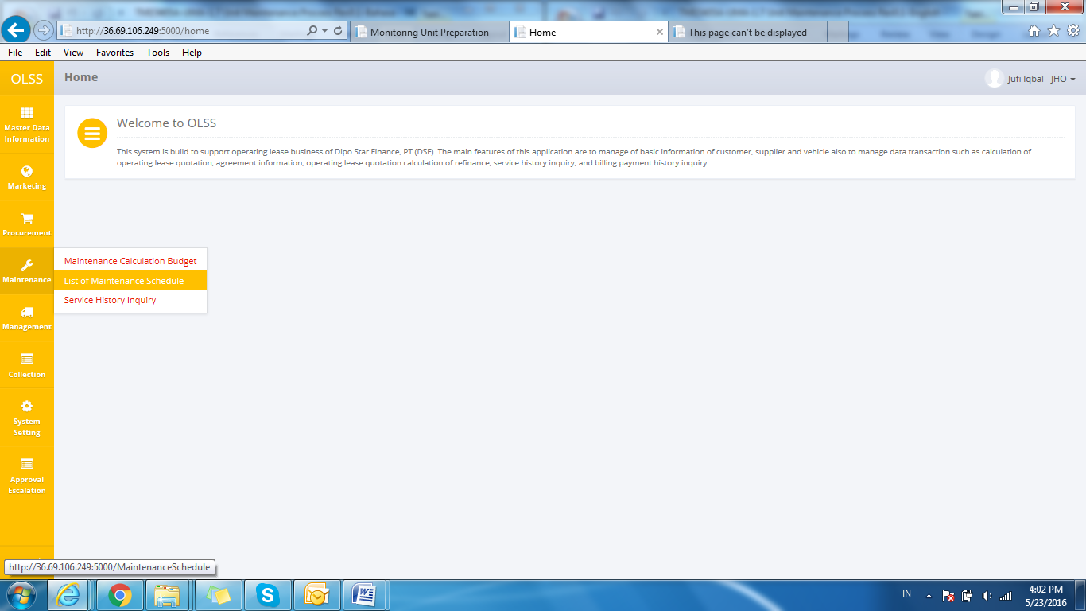

Screen 1: List of Maintenance Agreement Menu

1. System will show List of Maintenance Agreement screen that already recorded in the system. The main page of List of maintenance agreement is shown below:

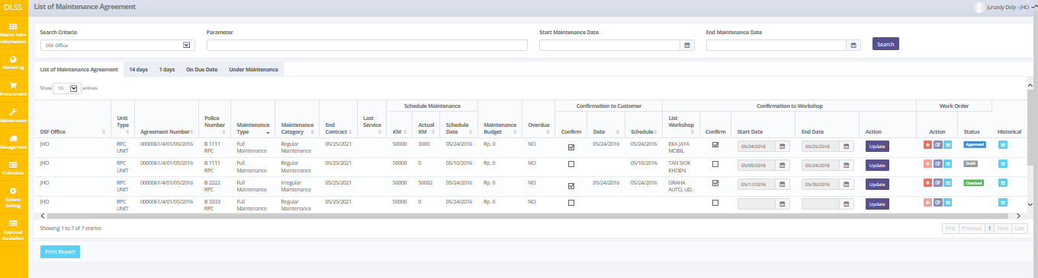

Screen 2: List of Maintenance Agreement

User can see information such as:

DSF Office, Unit Type, Agreement Number, Police Number, Maintenance Type, Maintenance Category, End Contract date, Last Service date, KM (Schedule Maintenance), Schedule Date (Schedule Maintenance), Maintenance Budget, Overdue, Confirm row (Confirmation to Customer), Date (Confirmation to Customer), Schedule (Confirmation to Customer), List Workshop (Confirmation to Workshop), Confirm row (Confirmation to Workshop), Start Date (Confirmation to Workshop), End Date (Confirmation to Workshop), Action row (Confirmation to Workshop), Action row (Work Order), Status (Work Order), Historical.

On the List of Maintenance Agreement screen, there will be seven buttons, which are:

* 1. : In the action column in Confirmation of Workshop column, click the button to update maintenance agreement schedule.
  2. : In the action column in Work Order column, click the button to create work order.



* 1. : In the action column in Work Order column, click the button to modify work order information.
  2.  : In the action column in Work Order and Historical column, click the button in Work Order column to view detail work order (navigate List of Work Order screen), and click the button in Historical column to navigate Detail History of Unit screen.
  3. : In the action column in Work Order column, click the button to print work order form.
  4. : On bottom-left screen, click the button to print report maintenance agreement list.

## Filter and Sort Agreement List

To filter the records there are three categories as follows:

1. To sort the record alphabetically by column, user can click  on the column title on the table header.
2. User can select the number of records that want to be showed by picking this feature  on the screen. If the records have been filtered based on number, the amount of records that will be shown is the same as the selected number.
3. User can filter the records with the specific information by entering the keywords on the search field shown below:

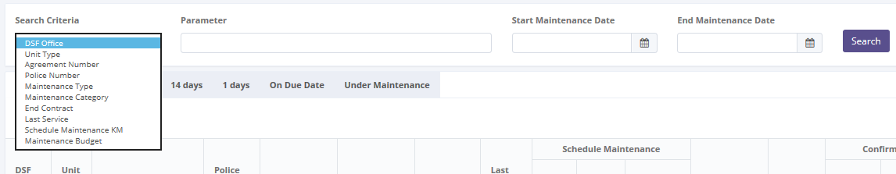

Screen 3: Search Criteria

Search criteria consist of data master:

Parameter can be filled with keywords that user want to search. To get more specific results, user can also insert the service date (Start Service Date and End Service Date). For example, you can find agreement number by filling the keywords in parameter, and pick **Agreement Number** in Search Criteria, then pick the exact date, and press Search button to get the results.

## Update/Input Maintenance Schedule

To update/input maintenance schedule record, navigate to the List of Maintenance Agreement and click Update button in the Action column of Confirmation to Workshop.

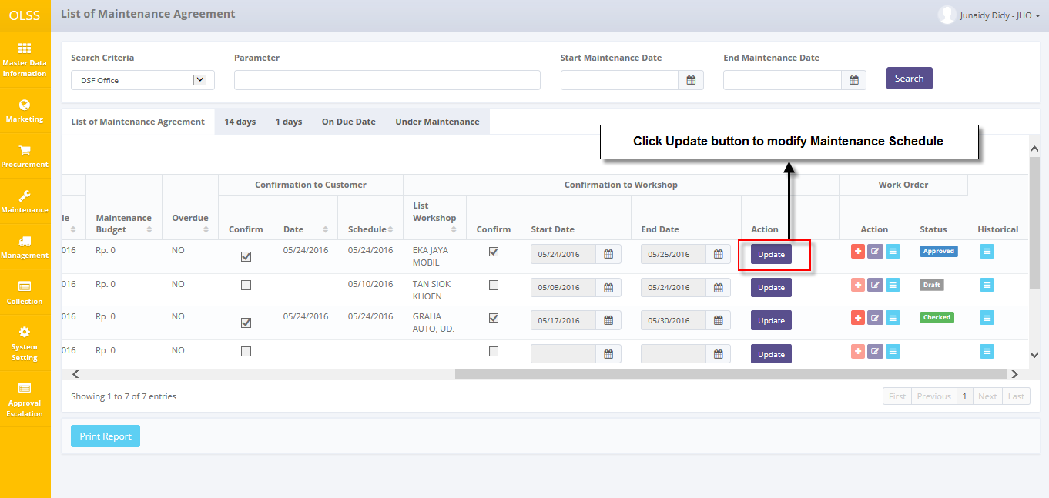

Screen 4: Navigate to Update Maintenance Schedule

The pop up below is shown after the Update button is clicked.

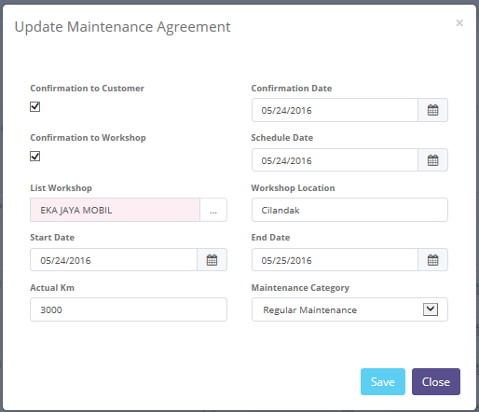

Screen 5: Screen of Update Maintenance Agreement

Once the Update Maintenance Agreement pop-ups open, user can input/update existed information. The fields are:

1. Confirmation to Customer: display current date. Checklist on Confirmation to Customer for enabled Schedule Date, if the schedule date want to editted.
2. Schedule Date: input schedule date to maintenance unit.
3. Confirmation to Workshop: checklist on Confirmation to Workshop for enabled Start Date and End Date Workshop, if the workshop date want to editted.
4. List Workshop: pick a workshop that will handle maintenance of customer unit.
5. Start Date: input start maintenance date.
6. End Date: input end maintenance date.
7. KM: update the actual mileage in KM (kilometre).
8. Category MT: pick a maintenance category regular, irregular, or claim insurance.

There are two buttons that will be displayed on the pop up as follows:

1. 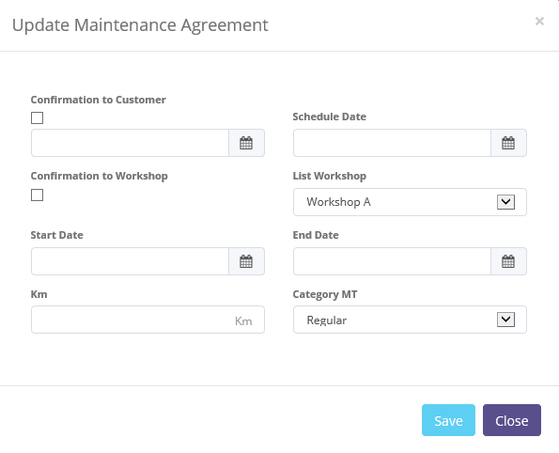, on the bottom-right corner of the screen, clicking this button to save updating maintenance schedule.
2. , on the bottom-right corner of the screen, clicking this button to close the pop up.

After clicking **Save** button, system will notified if it success or failed to save or submit a data. You also have a **Close** button, which redirect you to the previous page, List of Maintenance Agreement page.



Screen 6: Success notification after Save

## Print Maintenance Agreement Report

Aside from printing Maintenance Agreement report, user can print the entire maintenance list that has been recorded in the database. To print the report, user can click  button on the bottom of List of Maintenance Agreement Screen.

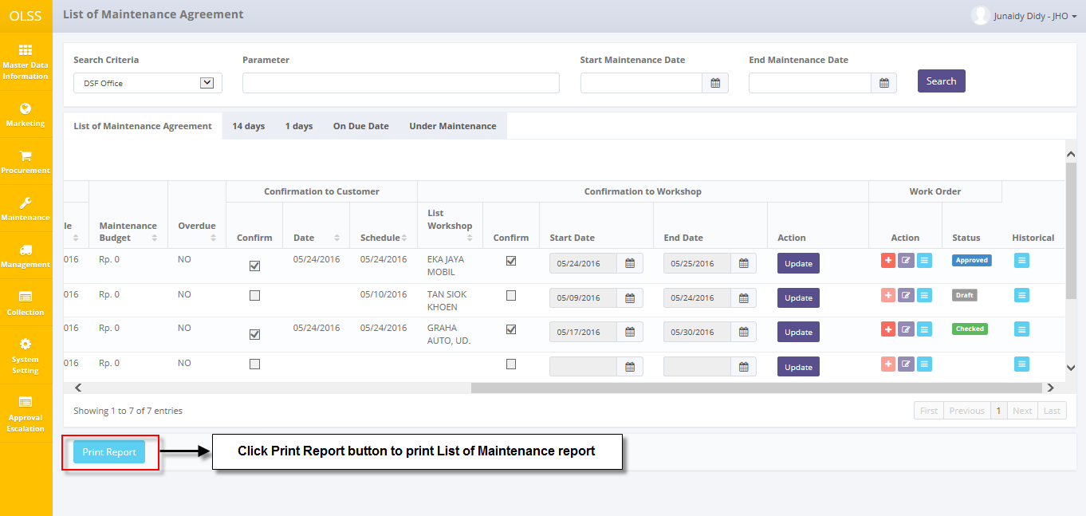

Screen 7: Navigate to Print Maintenance Report

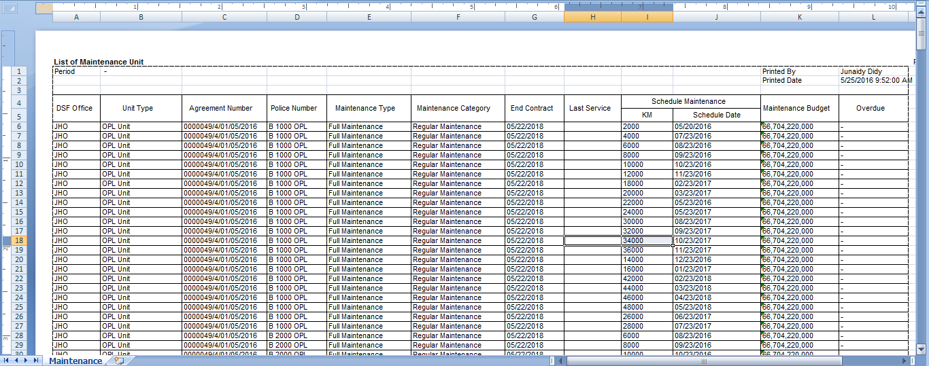

Screen 8: List of Maintenance Unit Report

# Manage Work Order

Unit that needed maintenance have request to the workshop with a work order document. Work order create for any condition/category regular, irregular and claim insurance.

Manage Work Order provides several functions:

1. Create new Work Order, within save as draft and/or submit.
2. Modify Work Order information; keep them up-to-date.
3. View details of Work Order to process approval information.
4. Print Work Order form.

Document statuses are divided into 6 types:

1. , the document hasn’t been submitted, still can be edited.
2. , the document can no longer be edited, and ready to be checked by DSF management.
3. , the document has been checked by DSF management, and continues to the next approval hierarchy.
4. , the document has some mistakes and the Checker has revised it. Document need to be submitted back by PIC Maintenance.
5. , the document has been approved by the highest hierarchy.
6. , the document has been rejected by the highest hierarchy.

## Create New Work Order

To create work order, find and click button 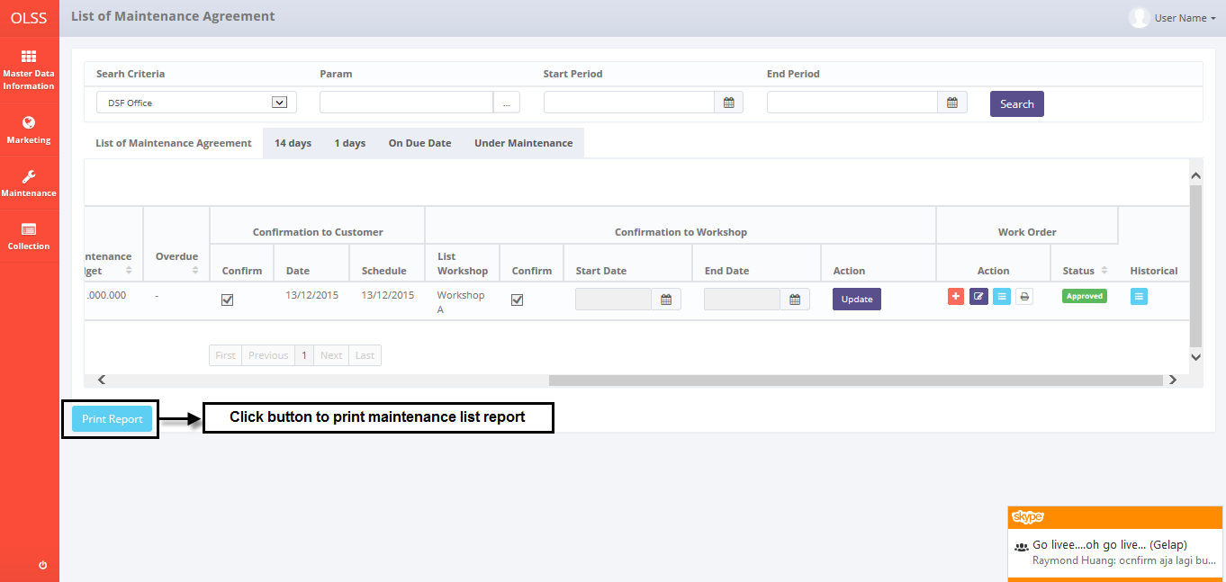 in Work Order column List of Maintenance Agreement.

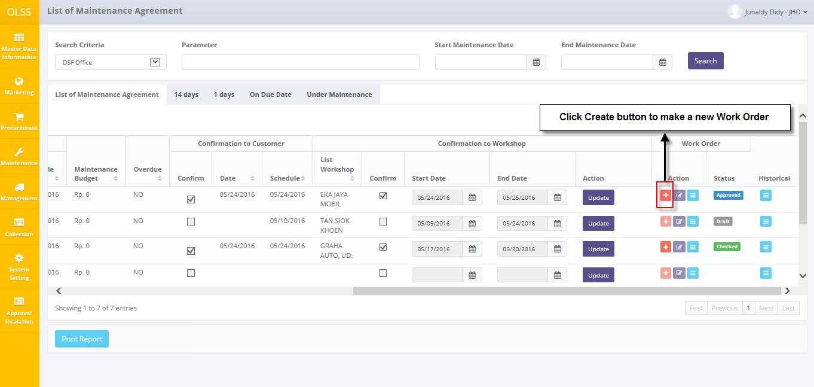

Screen 9: Navigate to Create Work Order

System will show Create Work Order Screen shown below:

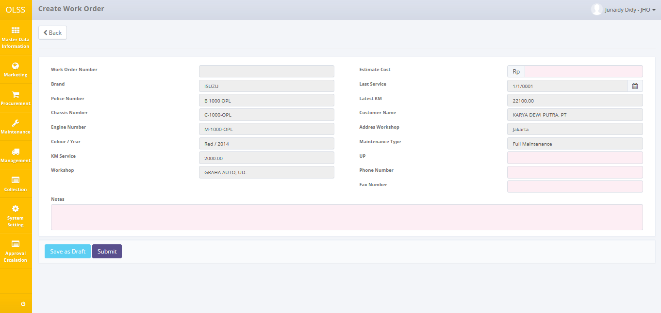

Screen 10: Screen of Create Work Order

Once the Create work order screens open, user has to fill information on the blank field. The fields are:

1. Estimate Cost: fill the estimation of maintenance cost. Only number can be inputted on Maintenance Cost.
2. UP: workshop PIC who can followed up.
3. Phone Number: input with phone number of workshop.
4. Fax Number: input with fax number of workshop.
5. Notes: fill any information/remark for task list maintenance.

There are three buttons that will be displayed on the screen as follows:

1. , on the top-left corner of the screen, to go back to previous screen: List of Maintenance Agreement.
2. , on the bottom-left corner of the screen, to save document as draft.
3. , on the bottom-left corner of the screen, to submit document.

After the data entered on the screen, user can save the information on the system by clicking **Save as Draft** button, or **Submit** button. Ensure that you actually want to **submit** a record, because the records can’t be reserved and update after submitted by user.

After clicking **Save as Draft** or **Submit** button, system will notified if it success or failed to save or submit a data.



Screen 11: Success notification after Save as Draft/Submit

## Edit a Draft Document of Work Order

To edit work order record, navigate to the List of Maintenance Agreement and click button in Work Order column with status  or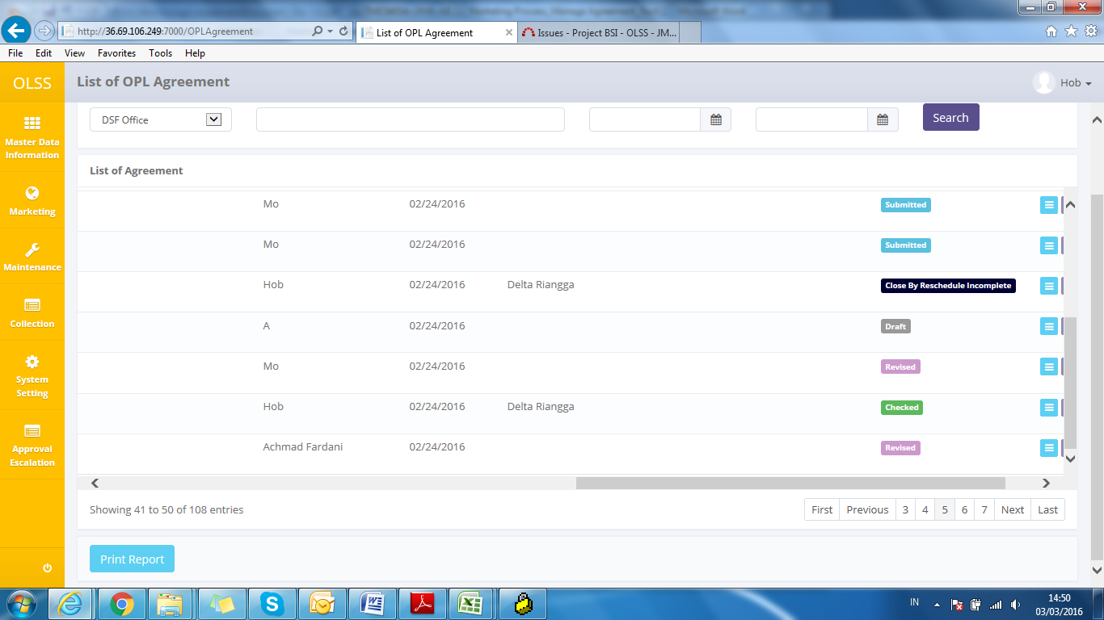.

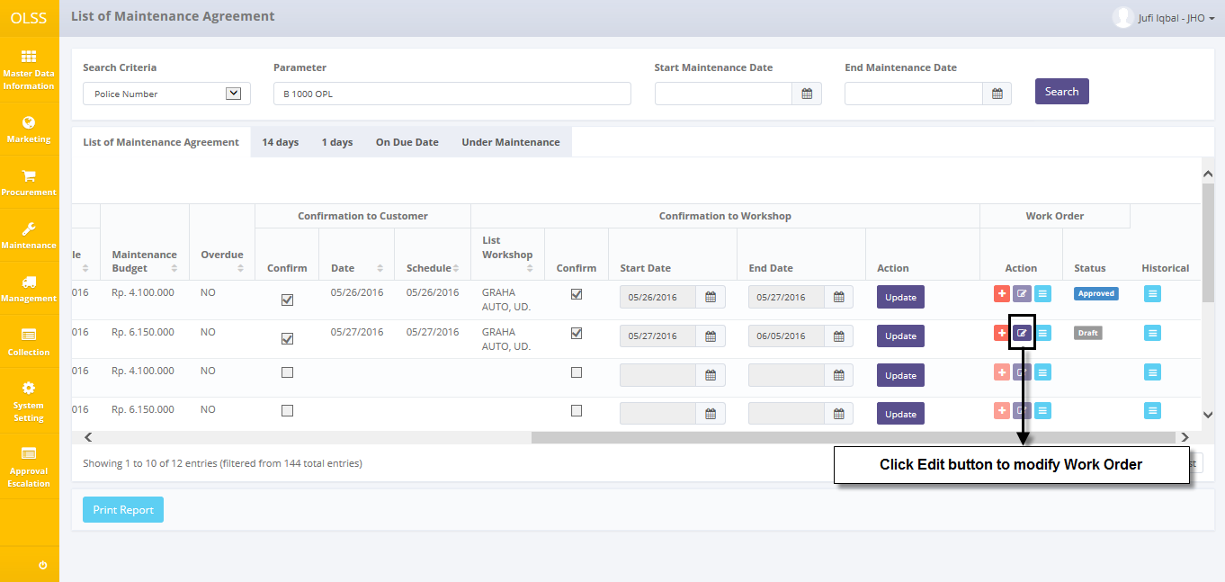

Screen 12: Navigate to Edit Work Order

The screen below is shown after the Edit button is clicked.

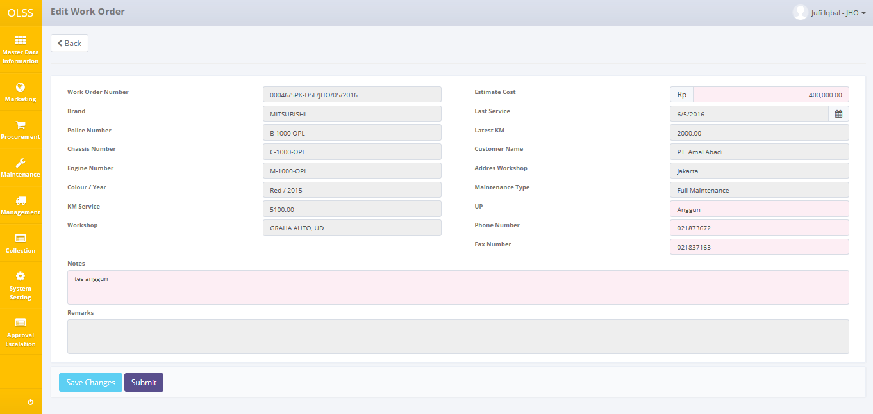

Screen 13: Screen of Edit Work Order

Once the Edit Work Order screens open, user can edit existed information (Maintenance Cost, Phone Number, and Remark). There are three buttons that will be displayed on the screen as follows:

1. , on the top-left corner of the screen, to go back to previous screen: List of Maintenance Agreement.
2. , on the bottom-left corner of the screen, clicking this will made Work Order status changed into .
3. , on the bottom-left corner of the screen, clicking this will made Work Order status changed into .

If data already changed on the screen, user can save a data on the system by clicking **Save Changes** button, or **Submit** button. Ensure that you actually want to **submit** a record, because the records can’t be reserved and update after submitted by user.

After clicking **Save Changes** or **Submit** button, system will notified if it success or failed to save or submit a data. You also have a **Back** button, which redirect you to the previous page, List of Maintenance Agreement page.



Screen 14: Success notification after Save Changes/Submit

## View a Work Order Detail

To view the records, you can select a record from the List of Maintenance Agreement page by clicking the action button in the Work Order column to navigate List of Work Order screen, then click again button  in Action column List of Work Order.

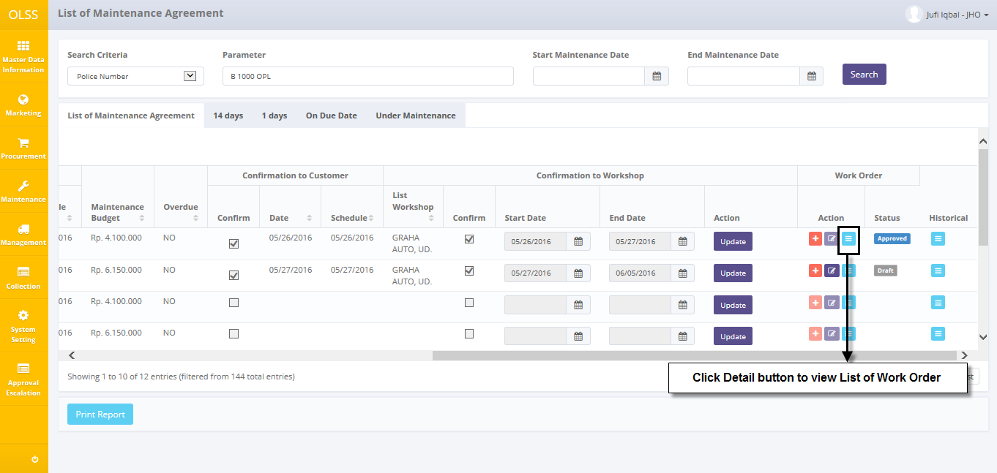

Screen 15: Navigate to View List of Work Order Screen

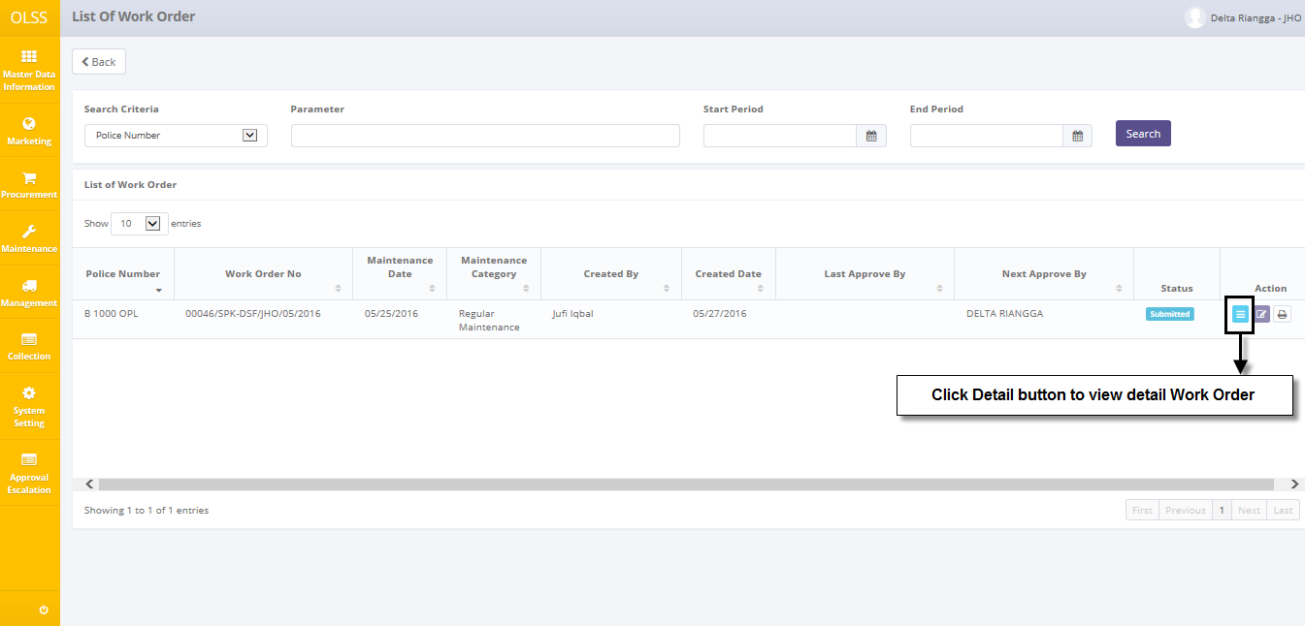

Screen 16: Navigate to View Detail Work Order

Screen will show view detail Work Order screen shown below:

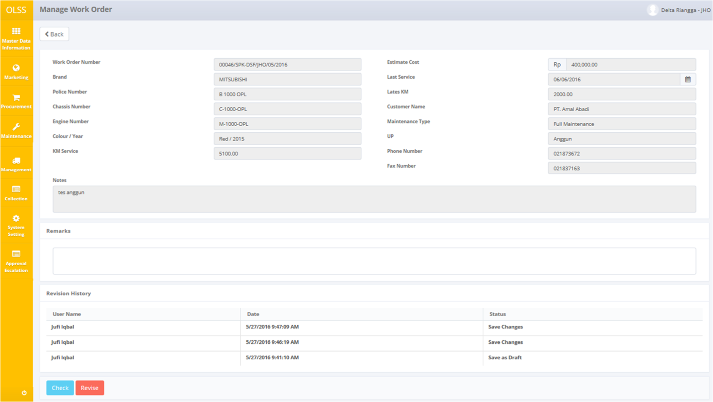

Screen 17: Screen Manage Work Order (Check and Revise)

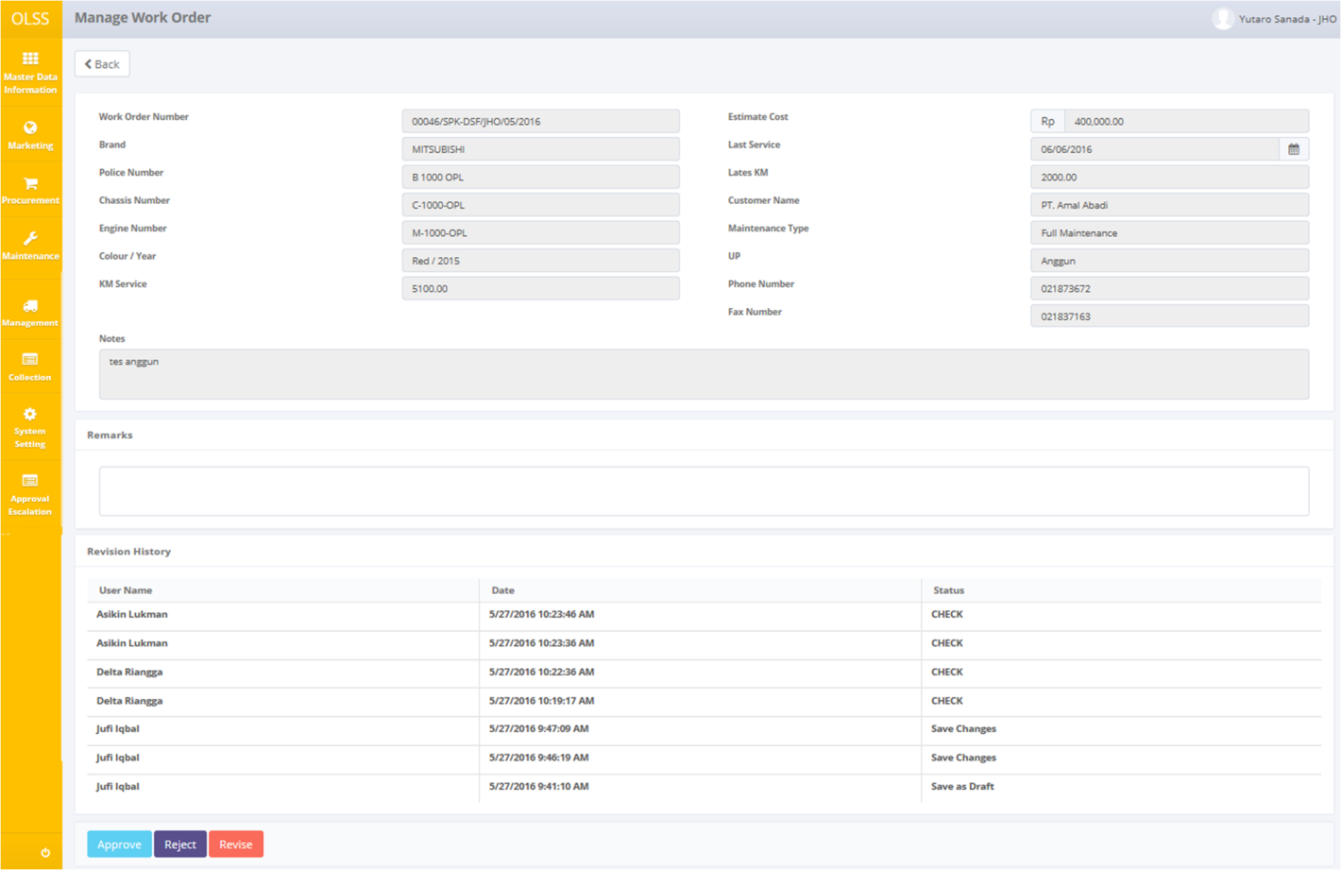

Screen 18: Screen Manage Work Order (Approve dan Reject)

User can check the records but the records cannot be clicked or edited. Here you can see the detail information related with Work Order Data, such as; Work Order Number, Maintenance Cost, Brand, Last Service, Police Number, Latest KM, Chasis Number, Customer Name, Engine Number, Phone Number, Colour/Year, Maintenance Type, KM Service, Remark. There are five buttons that will be displayed on the screen as follows:

1. , to go to previous screen: List of Work Order.
2. , to give a sign that current approver has check the document and ready to send the document to the next approver, will not active for the highest hierarchy approver (refer to nominal table). Work Order status will change to .
3. , to give a sign that user has approve the Work Order. Only active for highest hierarchy user. Work Order status will change to .
4. , to give a sign that the document need revision and have to be submitted again by PIC Maintenance. Work Order status will change to .
5. , to give a sign that document is rejected. Work Order Status will change to .

After clicking **Check, Approve, Revise** or **Reject** button, system will notified if it success or failed to save or submit a data.



Screen 19: Success notification after Work Order is checked



Screen 20: Success notification after Work Order is approved



Screen 21: Success notification after Work Order is revised



Screen 22: Success notification after Work Order is rejected

## Print Work Order Form

User can also print the records by clicking the button Print Form Work Order on the List of Work Order screen as shown below:

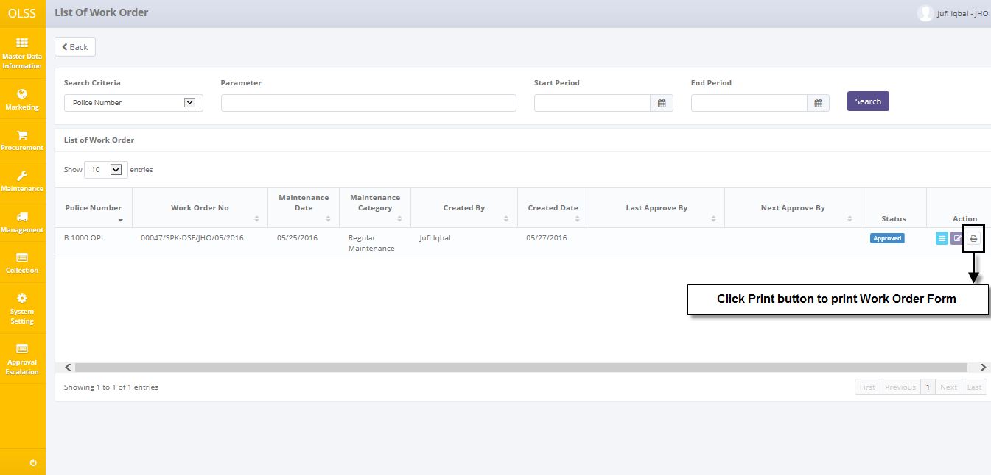

Screen 23: Print button on List of work Order

After clicking the button, system will show print preview of the Work Order form. User can choose to save document as Excel or PDF.

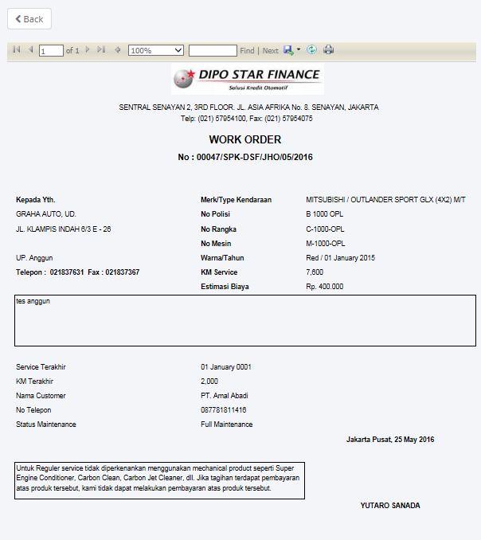

Screen 24: Print preview for Work Order Form

# Monitor Under Maintenance

Unit that under maintenance, will automatically listed in tab Under Maintenance – List of Maintenance Agreement menu. Under maintenance process also determine whether the unit requires replacement or not after confirmation to workshop.

Monitor under maintenance provides several functions:

1. Submit maintenance cost, within save changes and/or validate.
2. Modify under maintenance information; keep them up-to-date.
3. Print under maintenance unit report.

Document statuses are divided into 2 types:

1. Ongoing, the unit ongoing to maintenance, PIC Maintenance pick status ongoing.
2. Completed, the unit has been completed already, PIC Maintenance pick status completed.

## Submit Maintenance Cost

To submit maintenance cost, here is the procedure:

1. Click button  in action column on tab Under Maintenance – List of Maintenance Agreement.

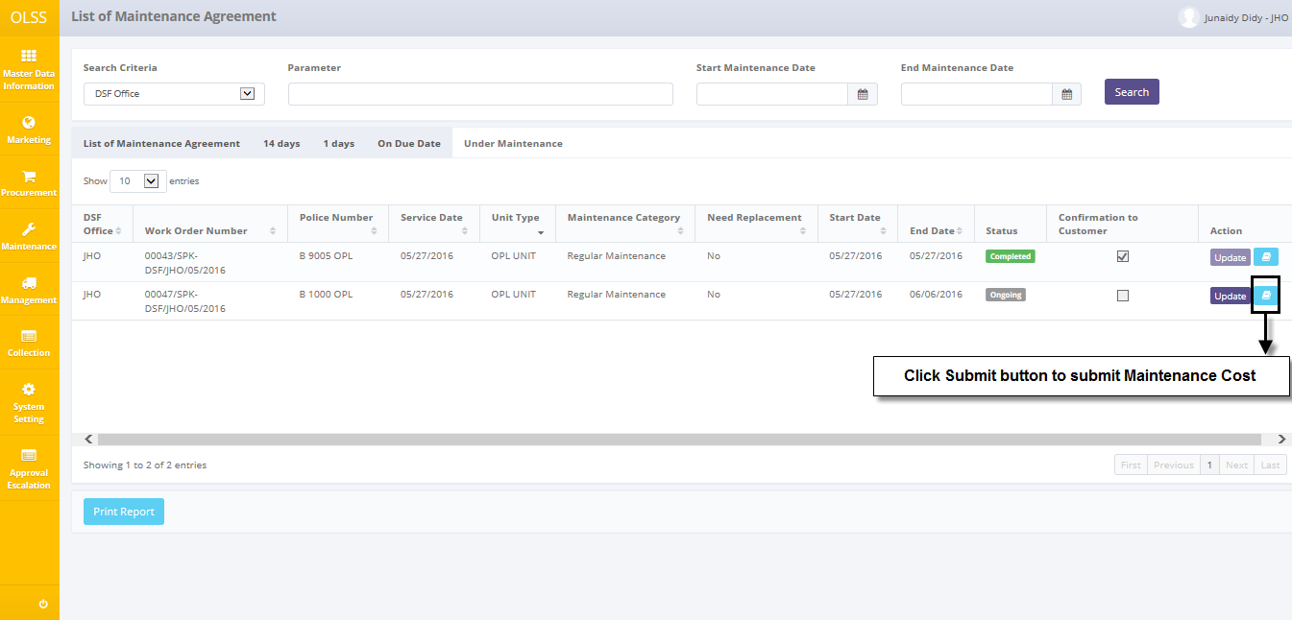

Screen 25: Navigate to Service History Inquiry Screen

1. System will show list of Detail History of Unit screen shown below:

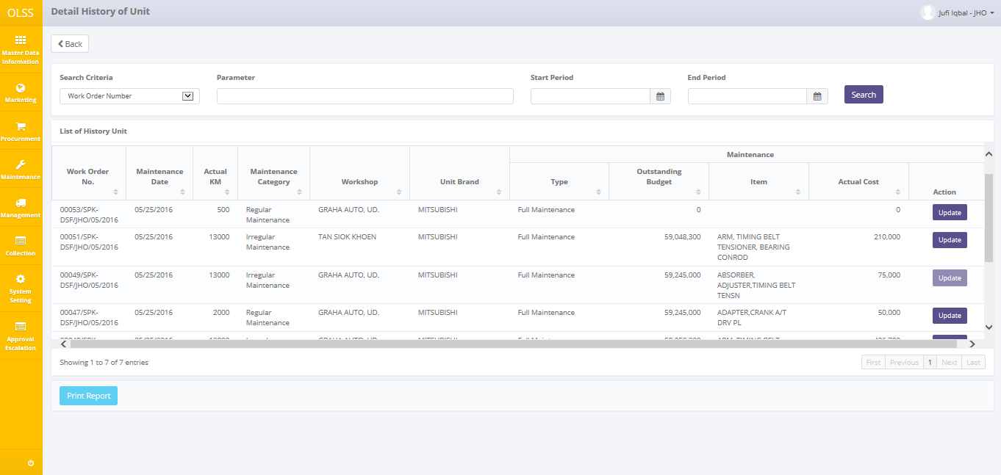

Screen 26: Screen Detail History of Unit

1. Navigate to input maintenance cost, click Update button on Action column shown below:

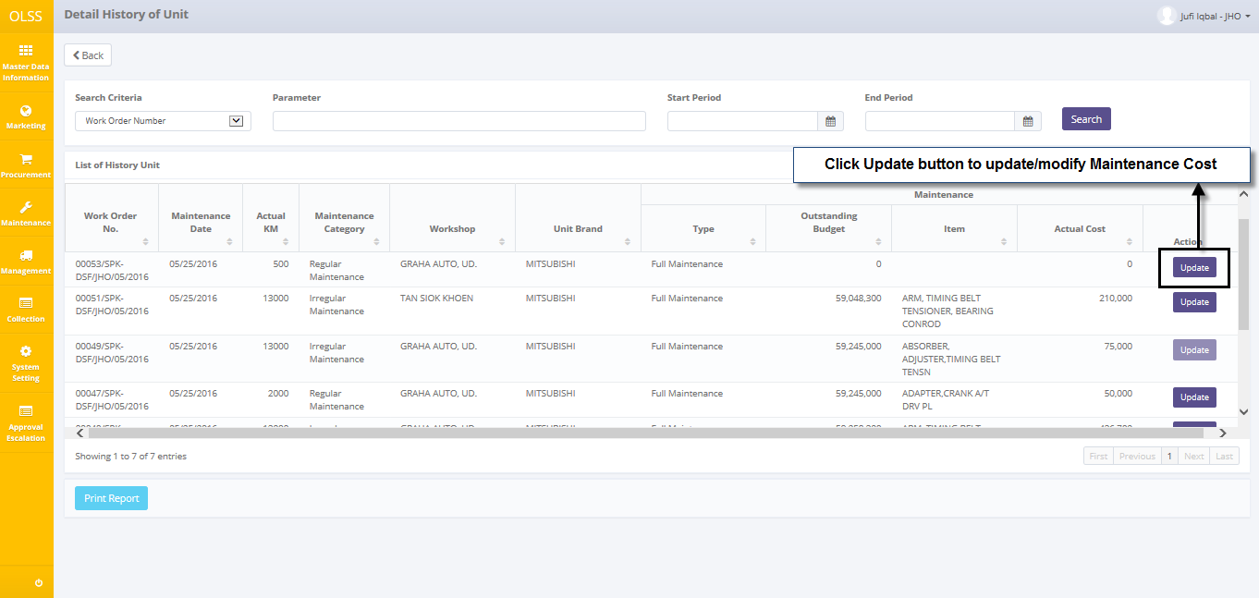

Screen 27: Navigate to Update Maintenance History of Unit Pop-up

1. System will show Update Maintenance History Unit pop-up shown below:

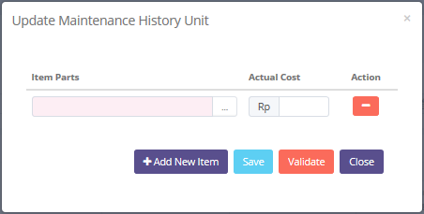

Screen 28: Pop up of Update Maintenance History Unit

Once the Update Maintenance History Unit pop-ups open, user has to fill information on the blank field. The fields are:

1. Item Parts: fill with information of implementation item.
2. Actual Cost: fill with amount of maintenance cost.

There are two buttons that will be displayed on the screen as follows:

1. , on Action column, to delete data row item part and maintenance cost.
2. , on the bottom-right of pop-up, to add item part and maintenance cost.
3. , on bottom-right of pop-up, to save data updated.
4. , on bottom-right of pop-up, to validate data maintenance history unit.
5. , on the bottom-right of pop-up, to go back to previous screen: Detail History of Unit.

After the data entered on the pop up, user can save the information on the system by clicking **Save** button. After clicking **Save** button, then validate by clicking **Validate** button, system will notified if it success or failed to add a data.



Screen 29: Success notification after Save/Validate

## Update a Under Maintenance Unit

To edit under maintenance unit record, navigate to the tab Under Maintenance – List of Maintenance Agreement and click Update button in action column.

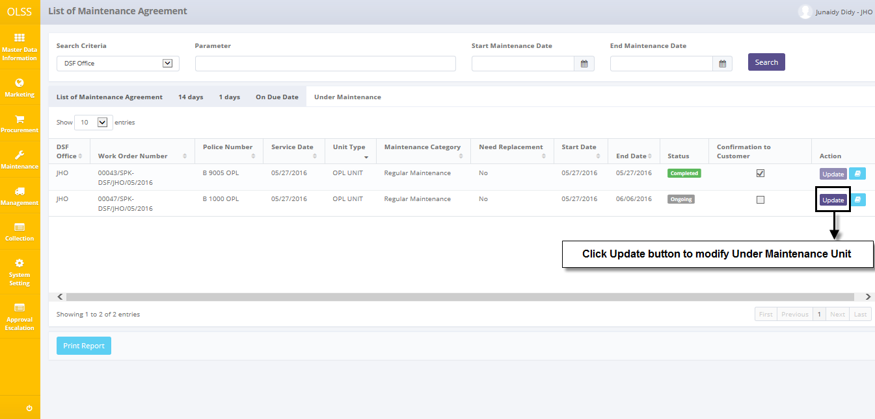

Screen 30: Navigate to Update under Maintenance Unit

The screen below is shown after the Update button is clicked.

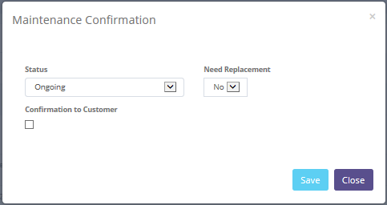

Screen 31: Maintenance Confirmation Pop up

Once the Maintenance Confirmation pop-ups open, user can edit existed information. The fields are:

1. Status: pick status of maintenance. Ongoing if unit ongoing to maintenance or Completed if unit has been completed already.
2. Need Replacement: pick Yes if the unit need replacement after confirmation to workshop or No if not.
3. Checking the Confirmation of Customer

There are three buttons that will be displayed on the screen as follows:

1. 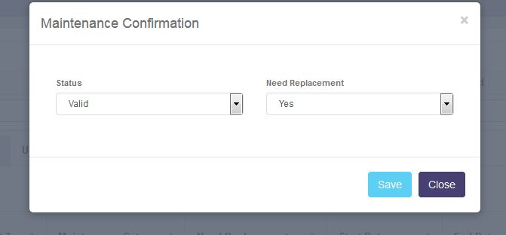, on the bottom-right corner of the pop up, clicking this button to save the maintenance confirmation and will change the status to be ongoing or completed.
2. , on the bottom-right corner of the pop up, to go back to previous screen: List of Maintenance Agreement.

After clicking **Save** button, system will notified if it success or failed to save a data. You also have a **Close** button, which redirect you to the previous page, List of Maintenance Agreement page.



Screen 32: Success notification after Save

## Print Under Maintenance Unit Report

Aside from printing under maintenance unit report, user can print the entire maintenance list that has been recorded in the database. To print the report, user can click  button on the bottom of tab Under Maintenance – List of Maintenance Agreement Screen.

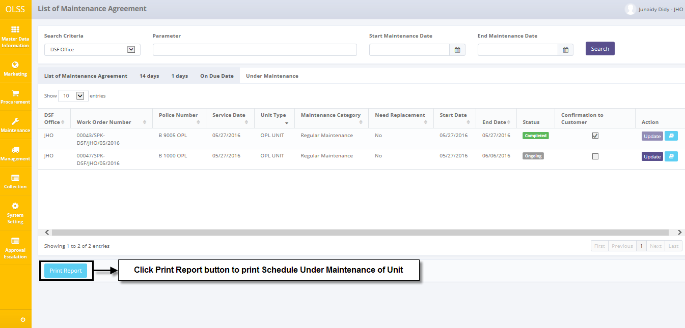

Screen 33: Navigate to Print Under Maintenance Report

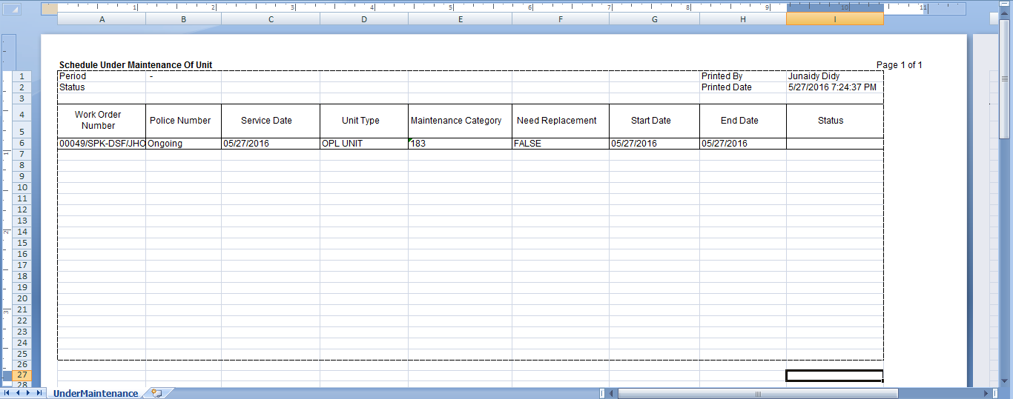

Screen 34: Under Maintenance of Unit Report

# Monitor Historical Maintenance

Unit that has been maintenance processed, will automatically in historical column List of Maintenance Agreement menu.

Monitor historical maintenance of unit provides several functions:

1. Show list of historical maintenance unit.
2. Print historical maintenance of unit report.

## Show List of Historical Maintenance Unit

To check the list of historical maintenance unit, here is the procedure:

1. Navigate to List of Maintenance Agreement menu and click button  on Historical column.

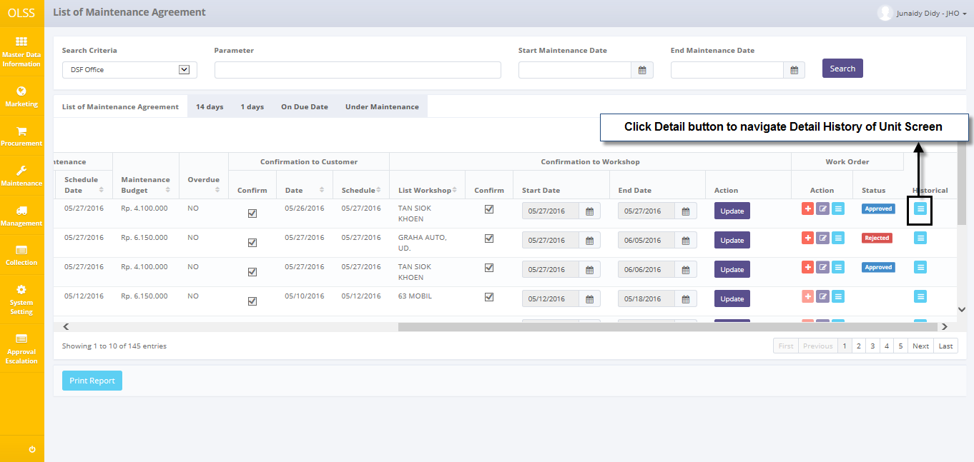

Screen 35: Navigate to Detail History of Unit Screen

1. System will show Detail History of Unit screen that already recorded in the system. The main page of Detail History of Unit is shown below:

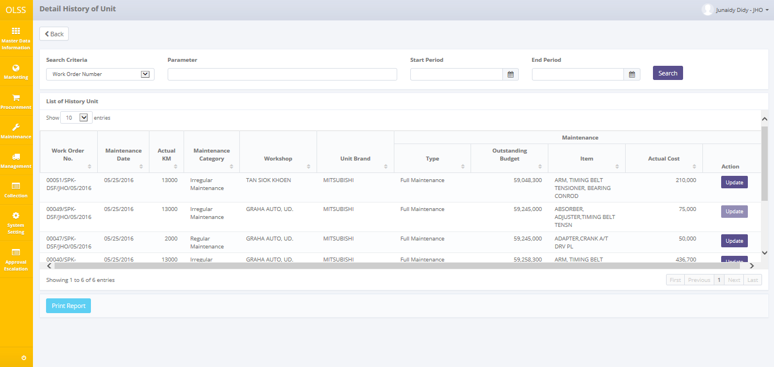

Screen 36: Detail History of Unit Screen

User can see information such as:

Work Order Number, Maintenance Date, KM, Service Type, Workshop, Unit Type, Maintenance Type, Maintenance Cost, and Maintenance Budget.

On the Detail History of Unit screen, there will be three buttons, which are:

* 1. , to go to previous screen: List of Maintenance Agreement.
  2. 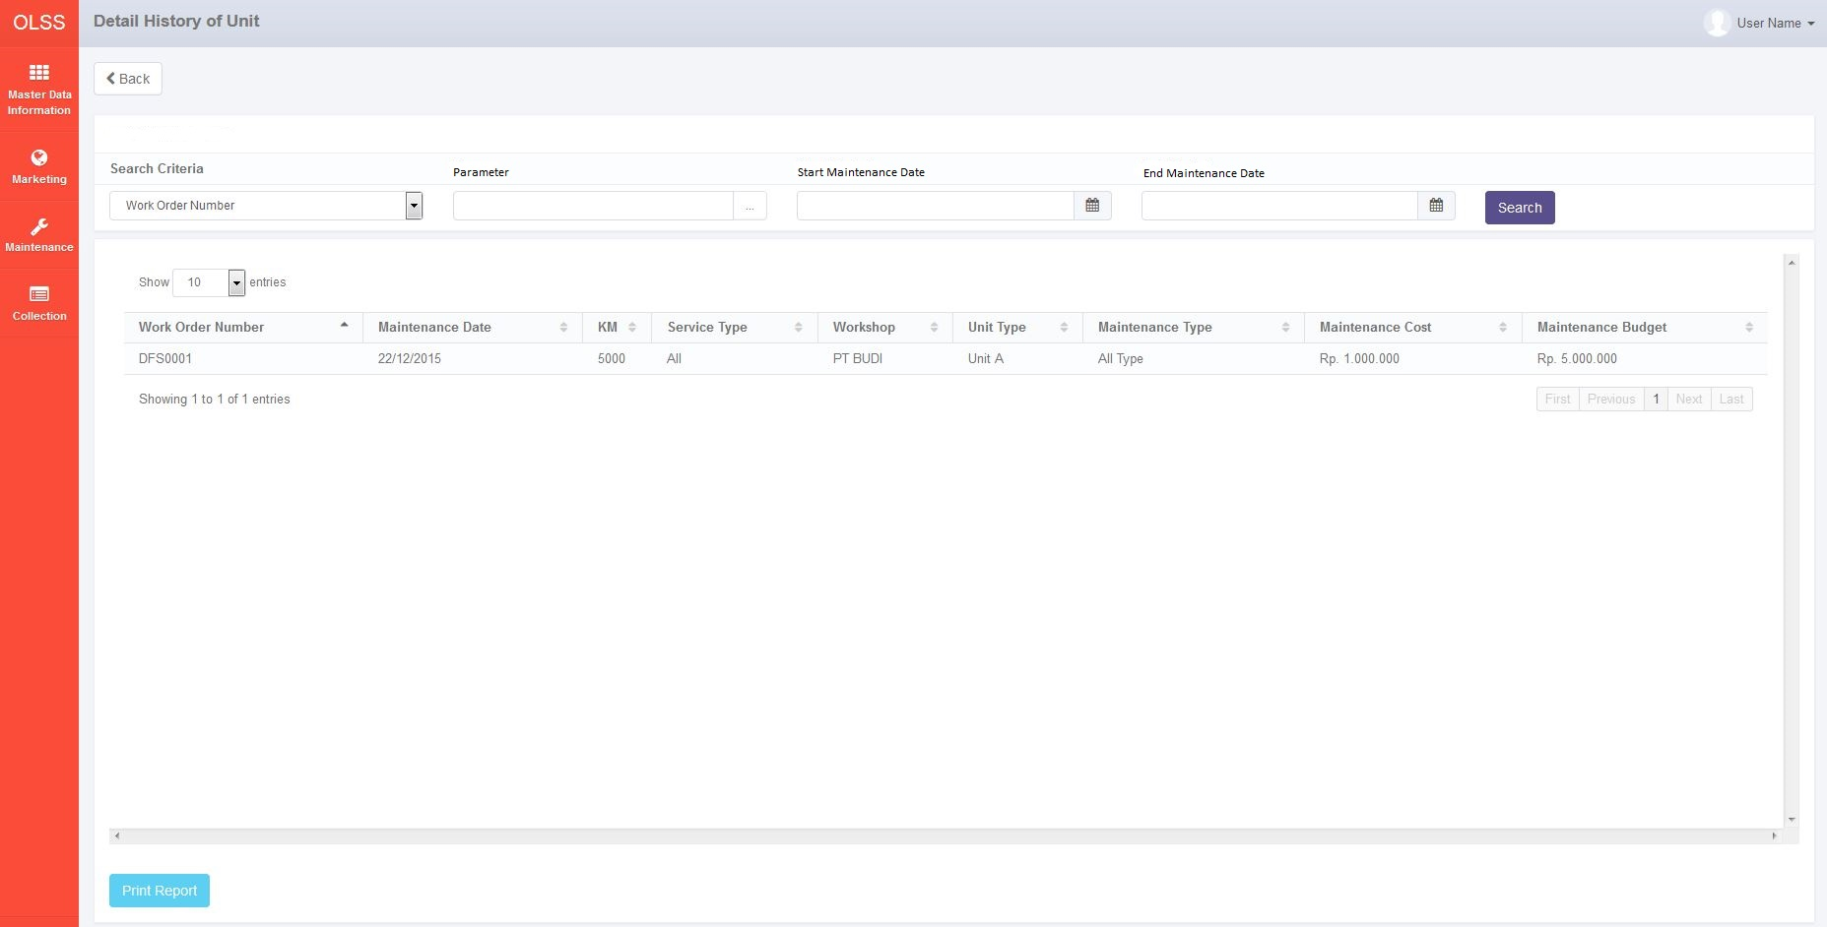, to displays data on List of Maintenance Agreement based on the selected criteria searching.
  3. : On bottom-left screen, click the button to print report list of historical maintenance unit.

## Print Historical Maintenance of Unit Report

Aside from printing historical maintenance of unit report, user can print the entire maintenance list that has been recorded in the database. To print the report, user can click  button on the bottom of Detail History of Unit screen.

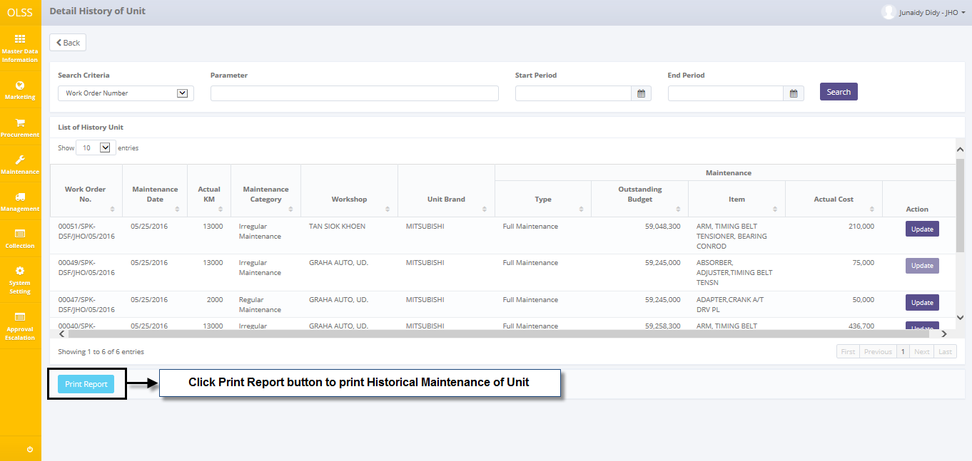

Screen 37: Navigate to Print Historical Maintenance of Unit Report

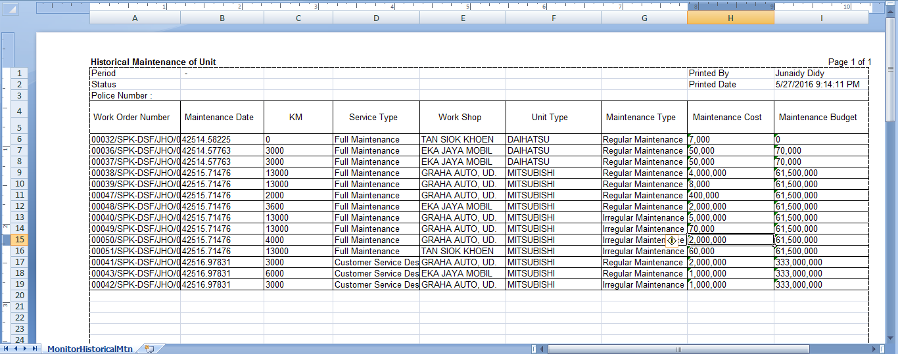

Screen 38: Historical Maintenance of Unit Report

# Maintenance Payment Expense

To submit maintenance expense, here is the procedure:

1. Navigate to List of Maintenance payment expense menu and click button  on top of page.

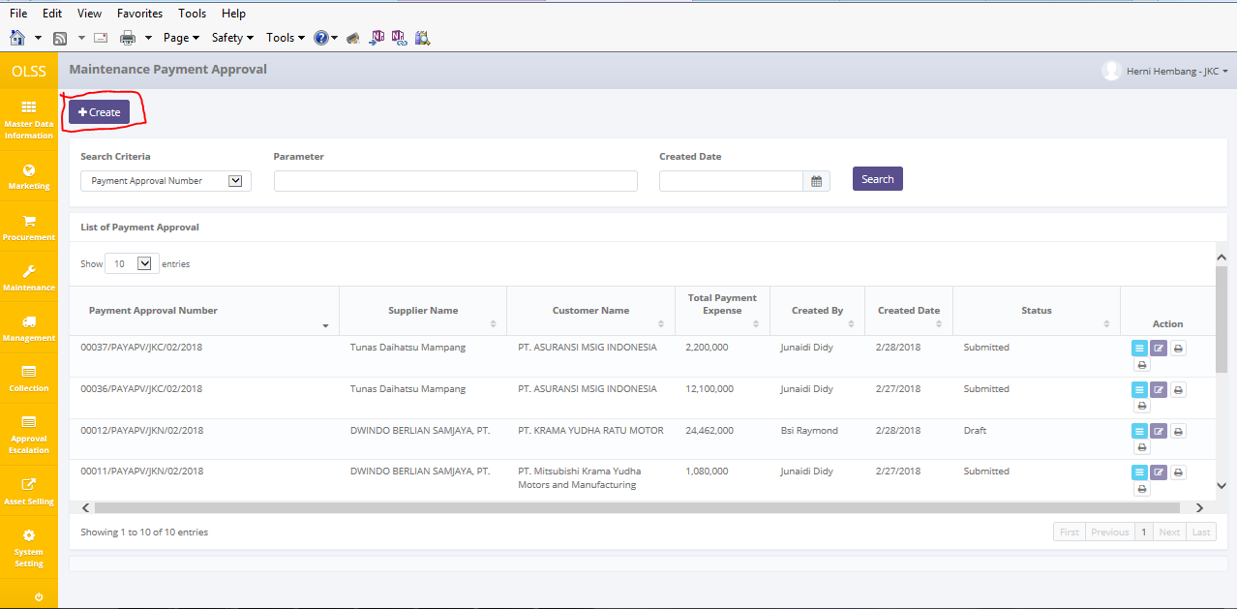

**Screen 39: List of Maintenance Expense**

1. Choose Supplier, choose work order number, choose customer, and fill all field with necessary data.

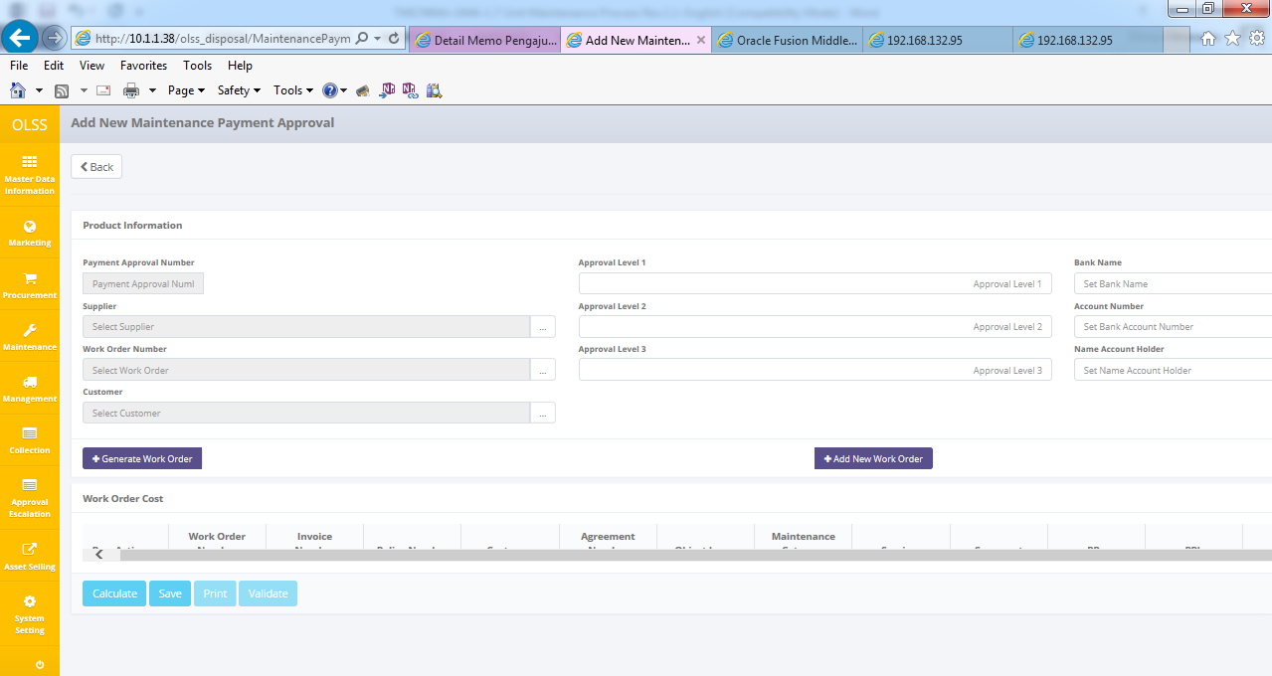

**Screen 40. Create Maintenance Expense**

1. Click generate work order, the data will list up on work order cost, fill the value for expense, and then click calculate to sum total expense, and last step is click save.

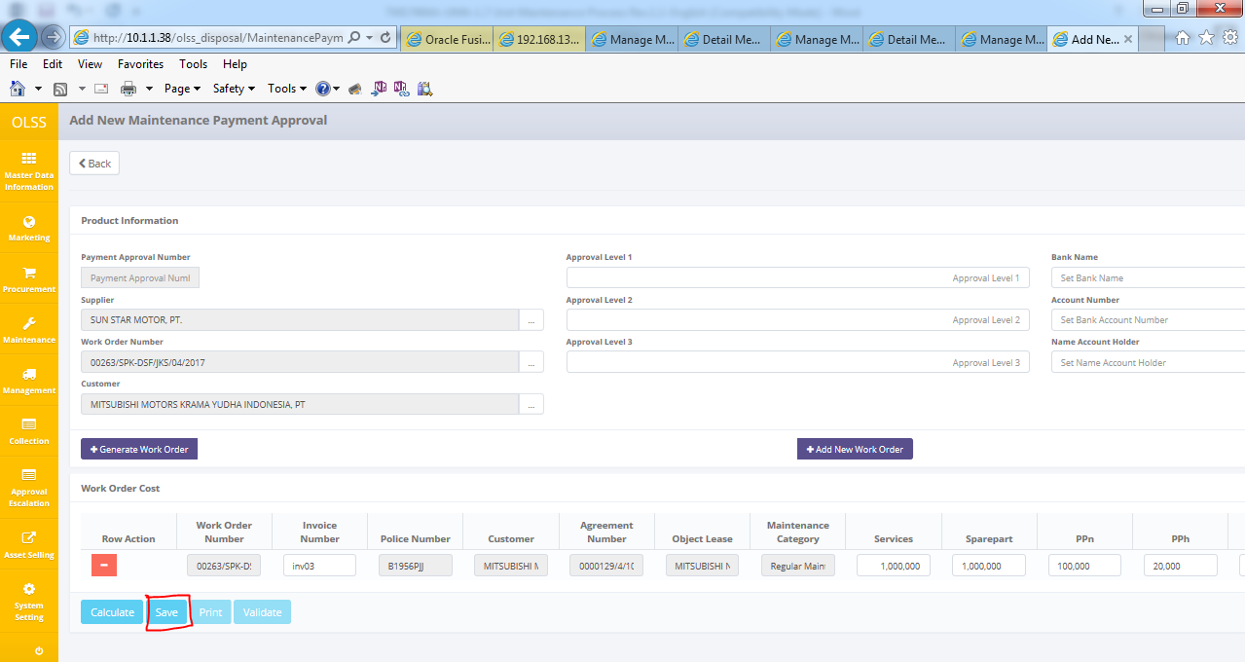

**Screen 41. Generate work order**

1. Notification success will appear after click save, the status will be draft.

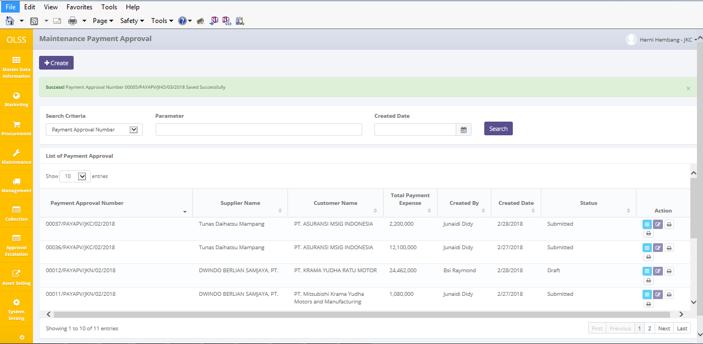

**Screen 42. Notification success**

1. Click edit and then click validate to lock the data.

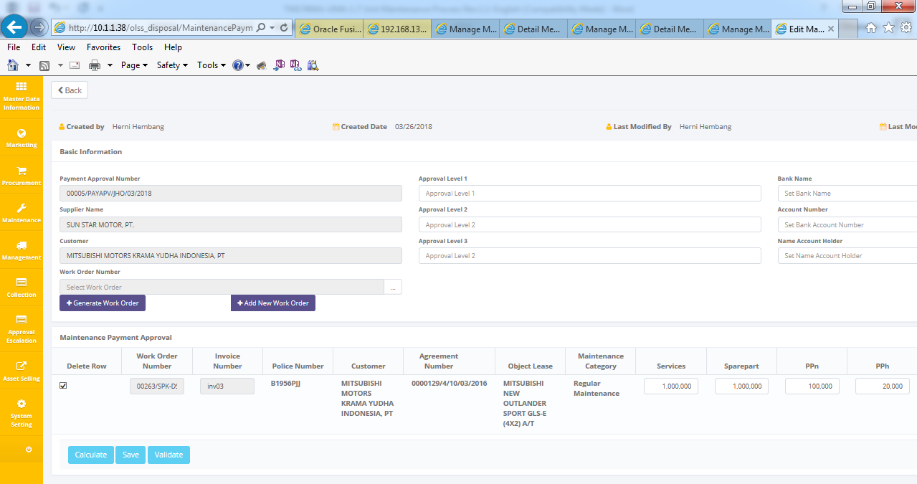

**Screen 43. Edit menu and validate data.**

1. Click Print button to print payment expense approval and payment expense upload text.

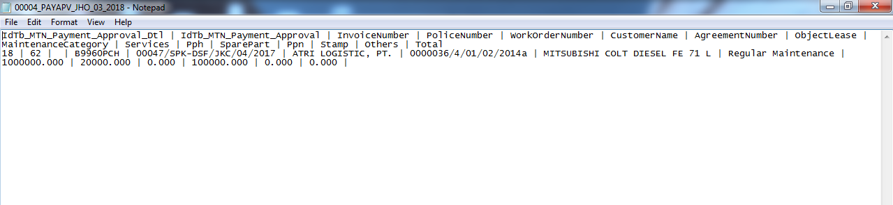

**Screen 44. Template Upload maintenance expense**

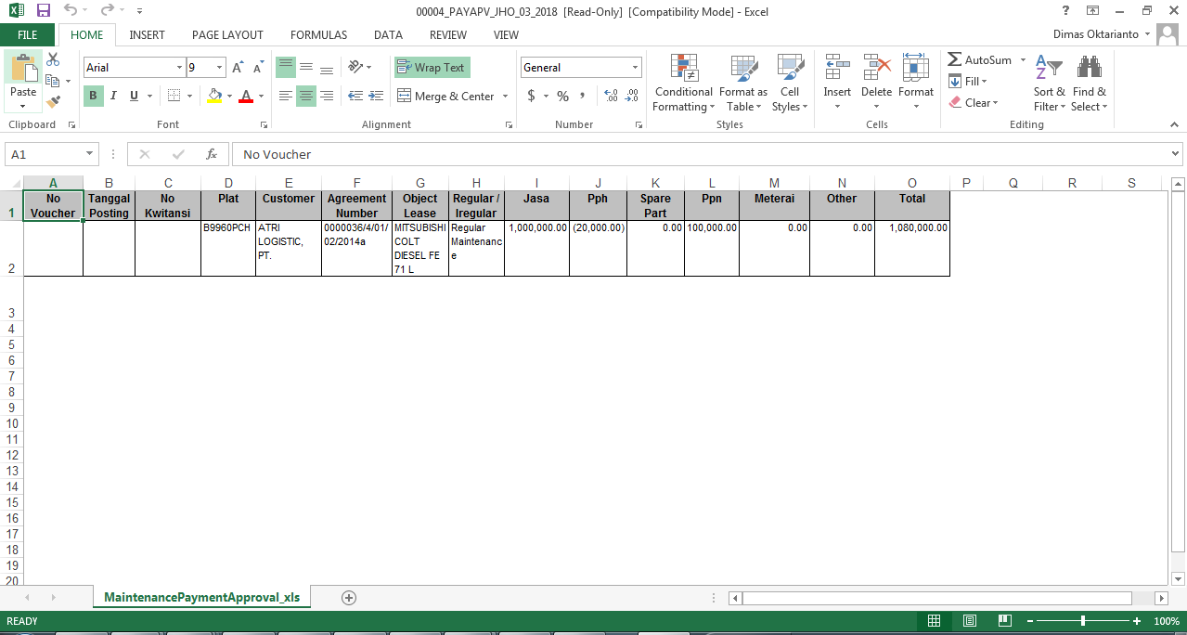

**Screen 45. Template Upload Maintenance Expense version excel**

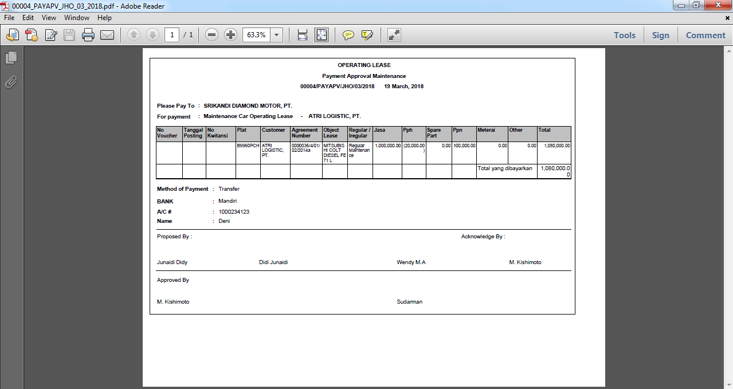

**Screen 46. Maintenance Expense Approval**

1. After get “bukti bayar” from treasury, SBD PIC will upload “bukti bayar” to OLS and then click paid.

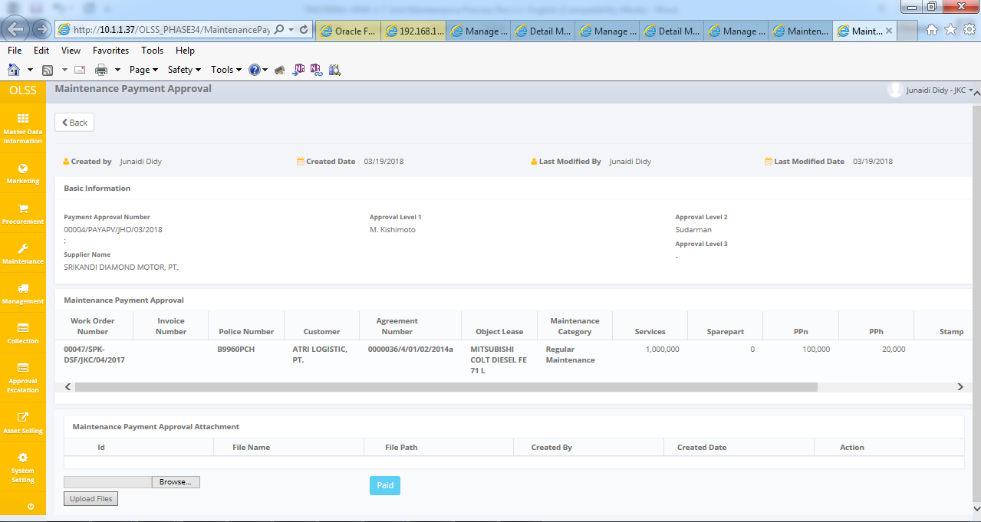

**Screen 47. Screen detail to upload “bukti bayar”**